**Task 1. Create and subscribe to an SNS topic**

**Services – Application Integration – Simple Notification Service**

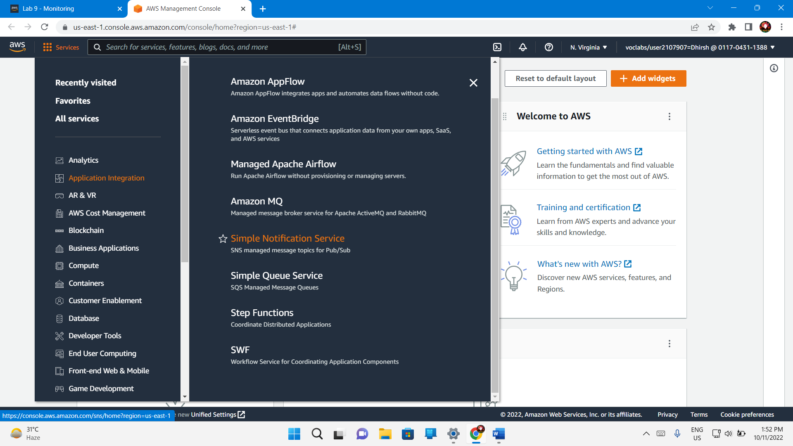

Left icon – Topic – Create Topic

A Topic acts as a communication channel where messages from alerts and events can be posted.

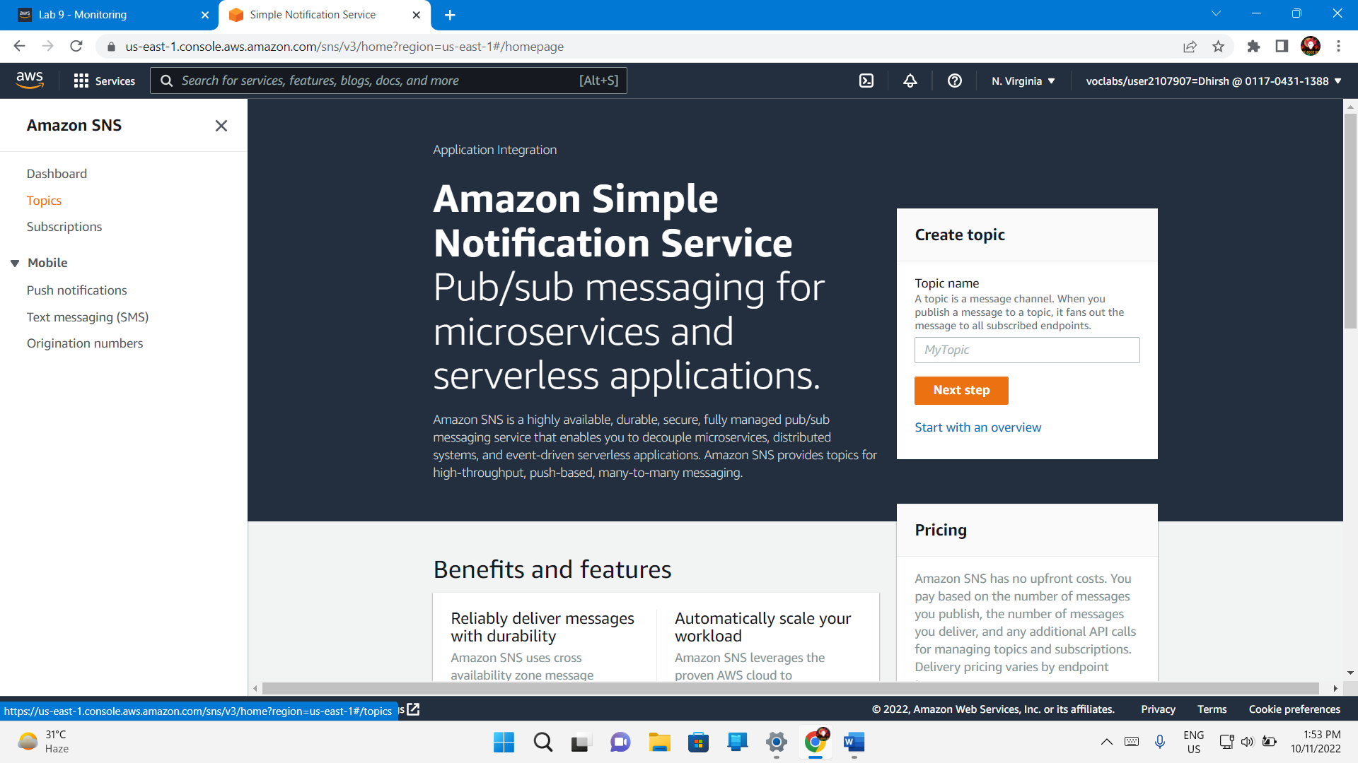

For **Type**, select **Standard**.

For **Name**, enter MoneyAlert

Choose **Create topic**

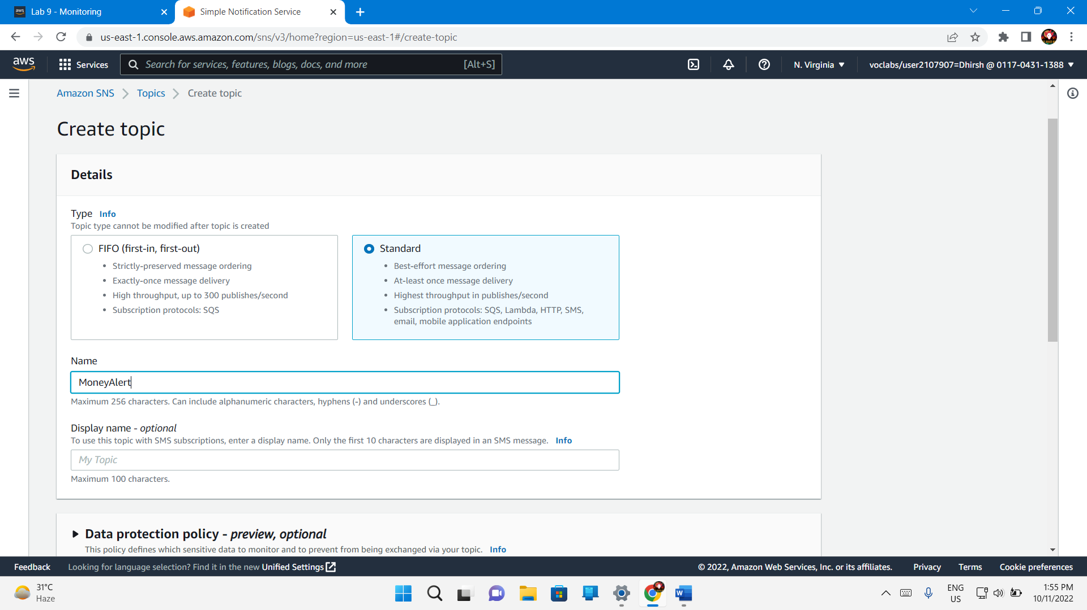

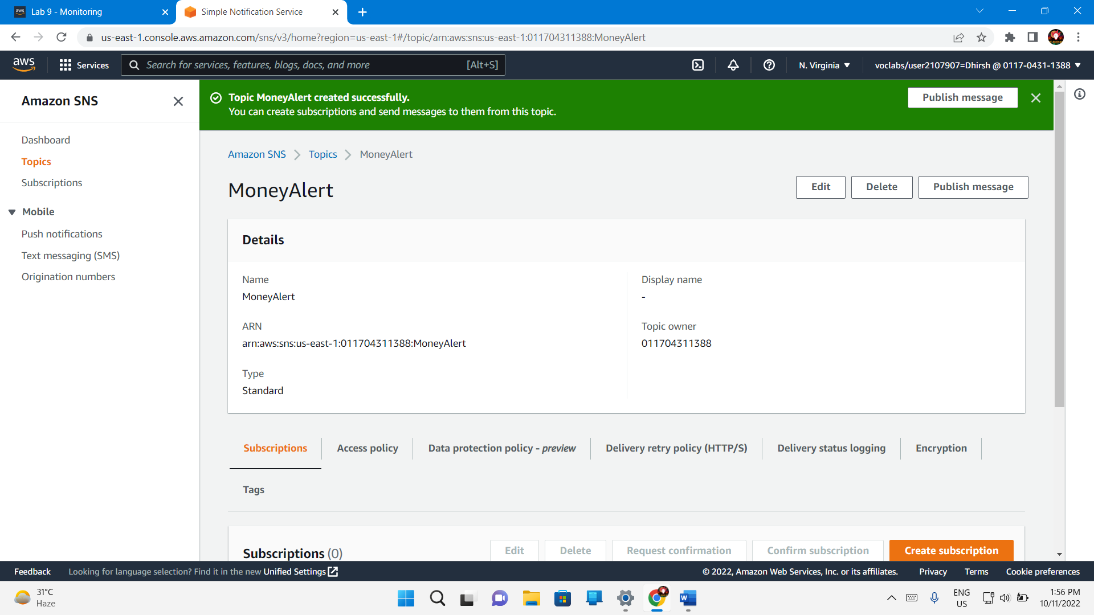

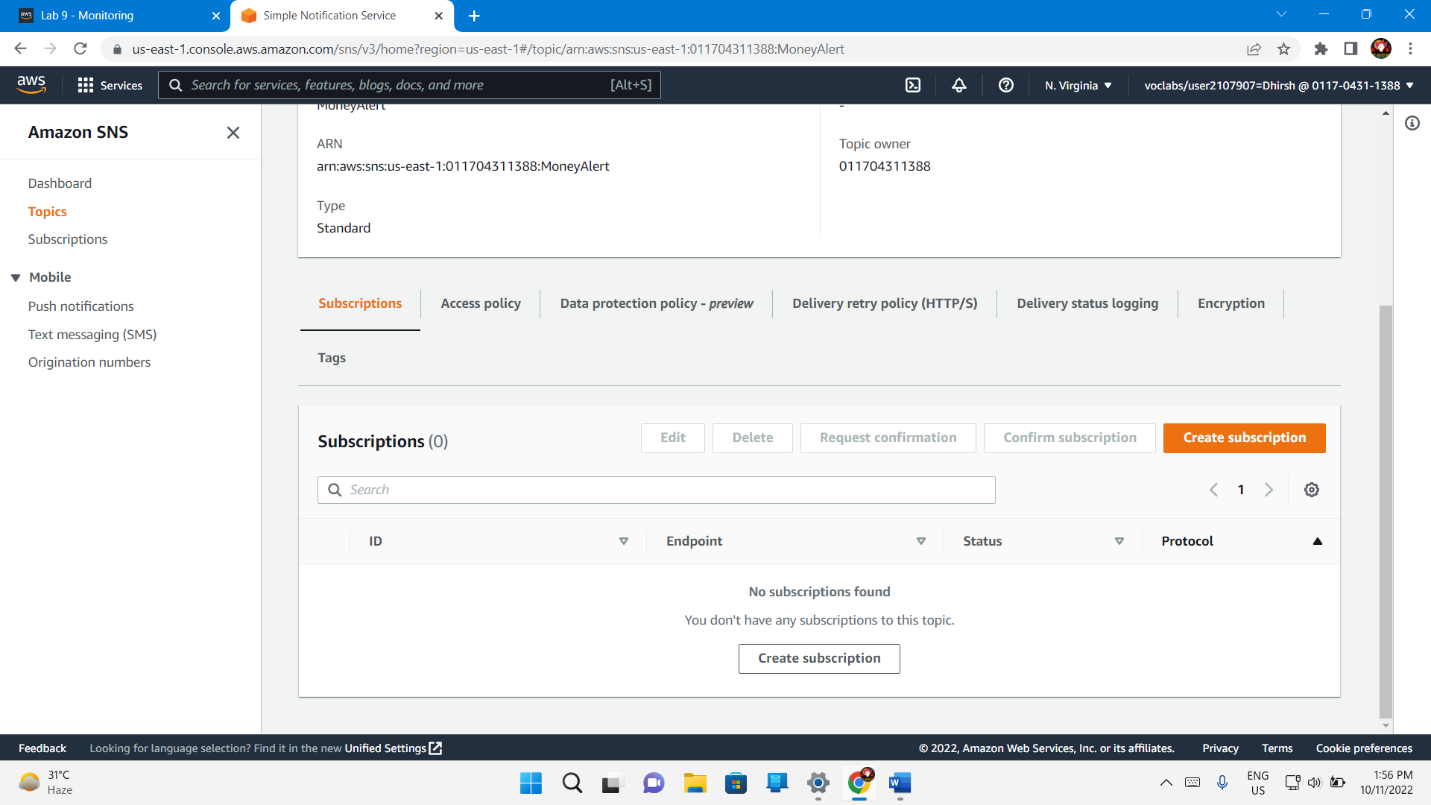

Subscription – Create Subscription

Topic Arn – MoneyAlert

Protocol – Email

Endpoint – Emailid or Phone number

Create Subscription

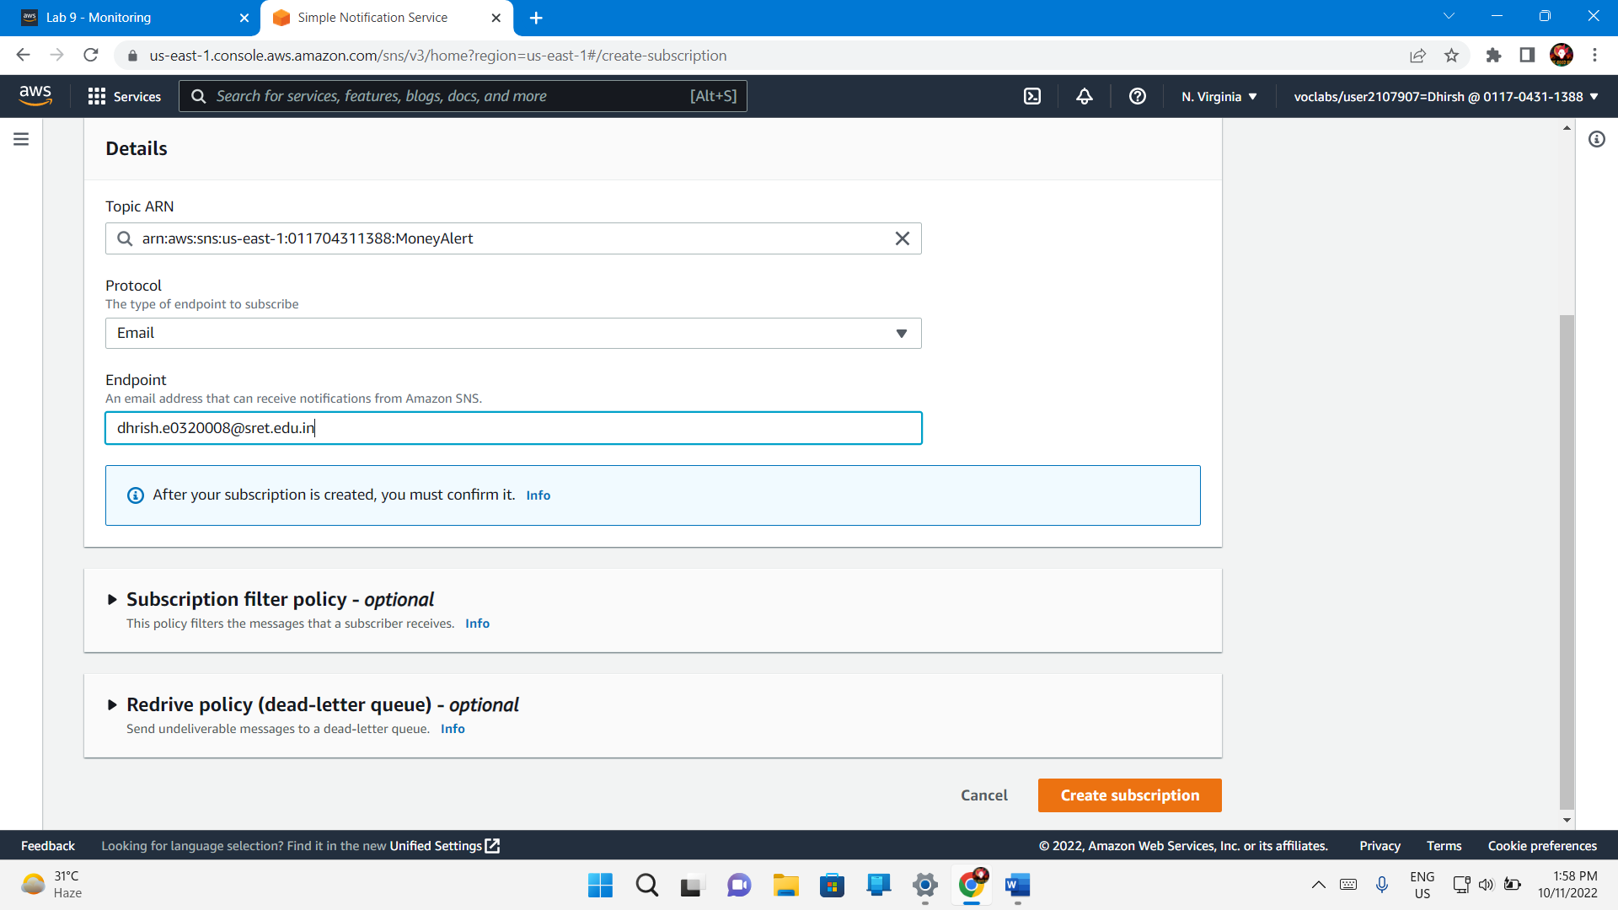

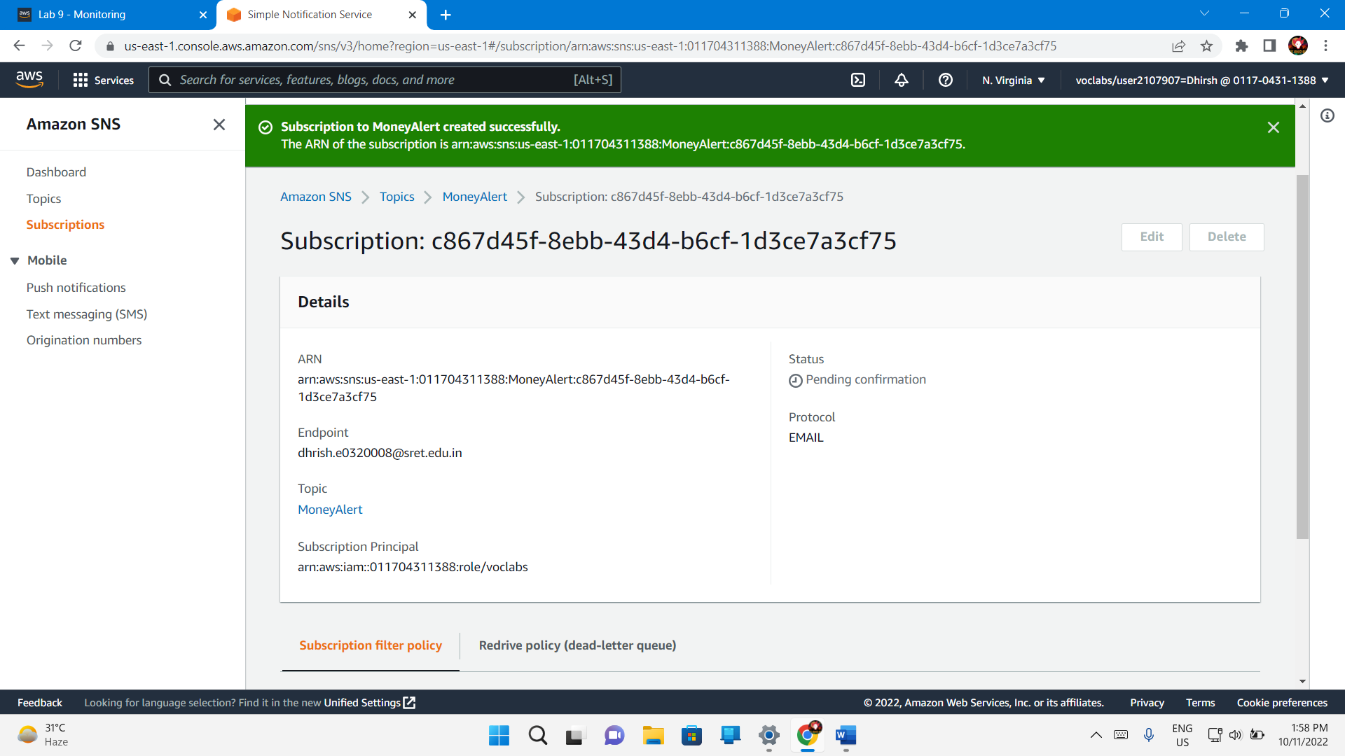

## Task 2. Create a CloudWatch alarm

Services – Management and Governance - CloudWatch

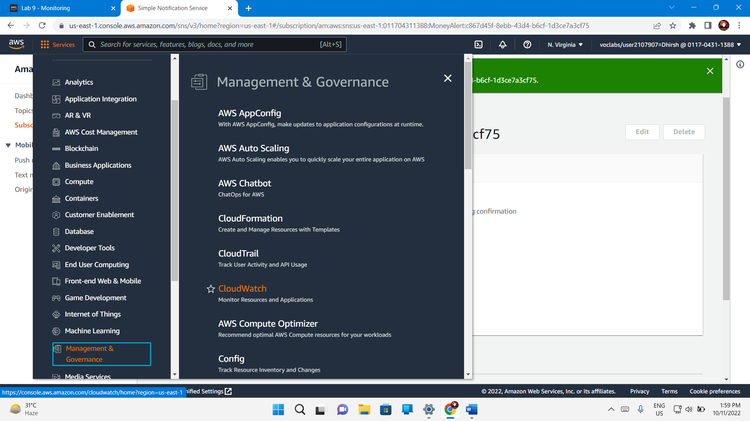

Alarms – All Alarms – Create alarm

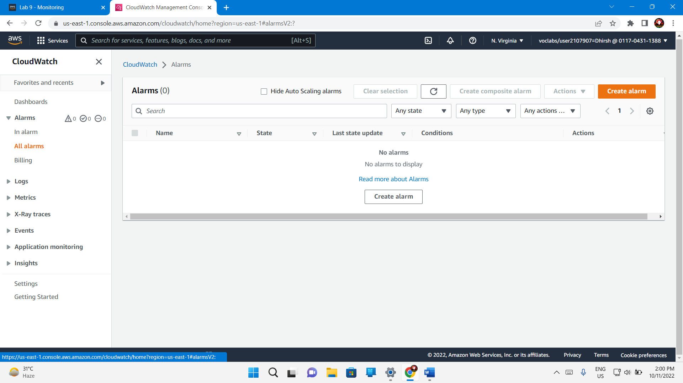

Select Metric

In the metric – Billing

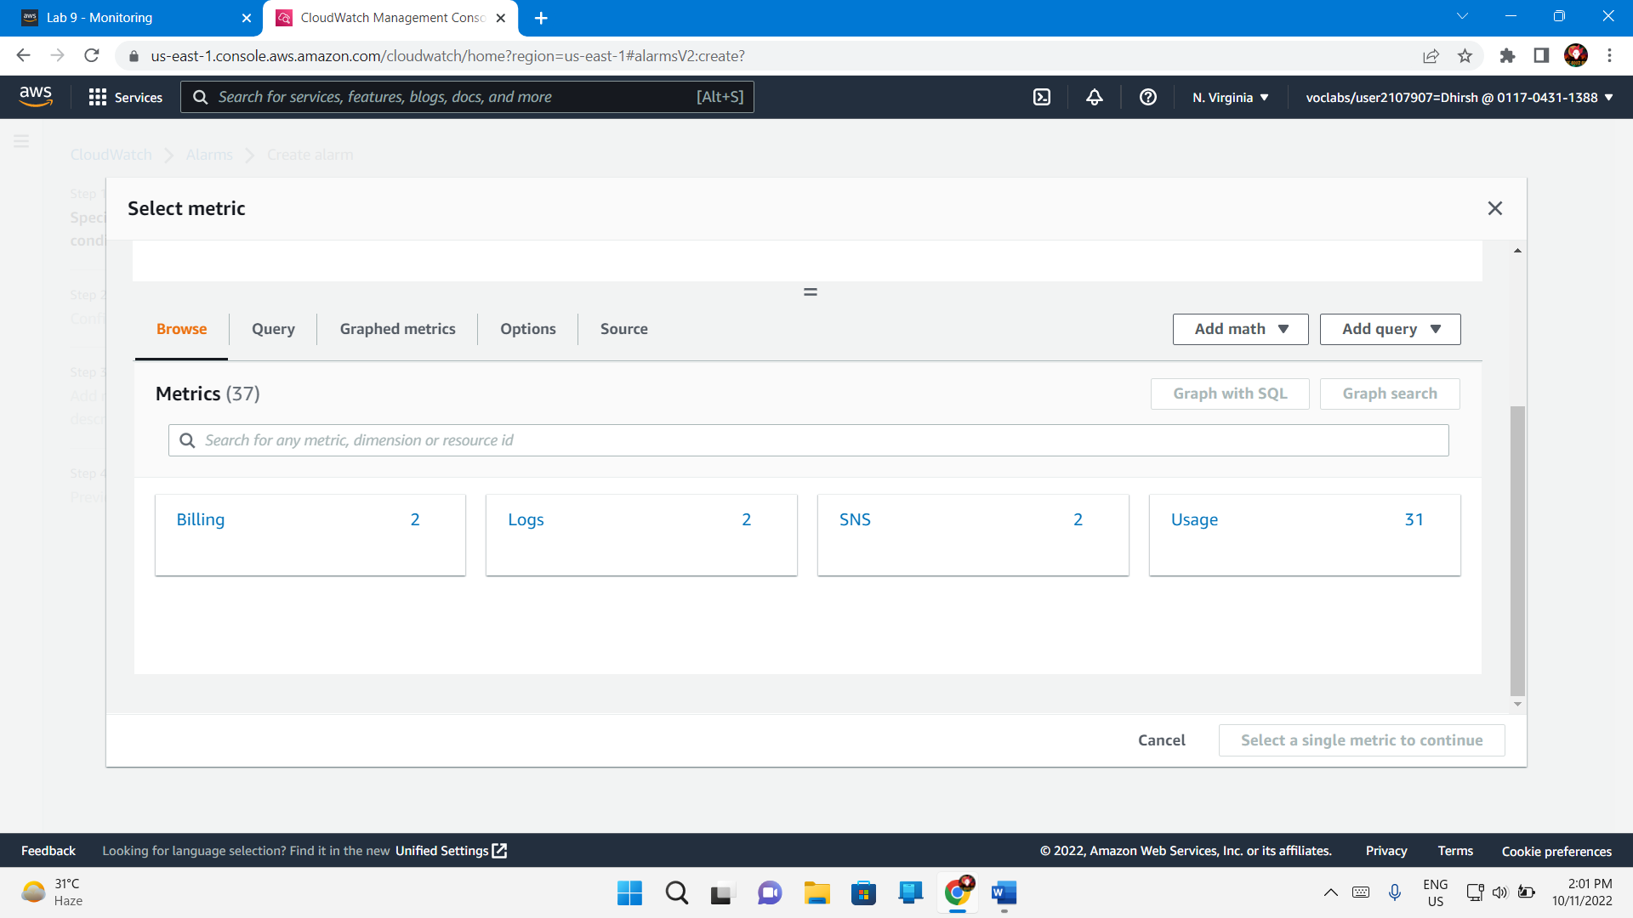

Total Estimated Charge

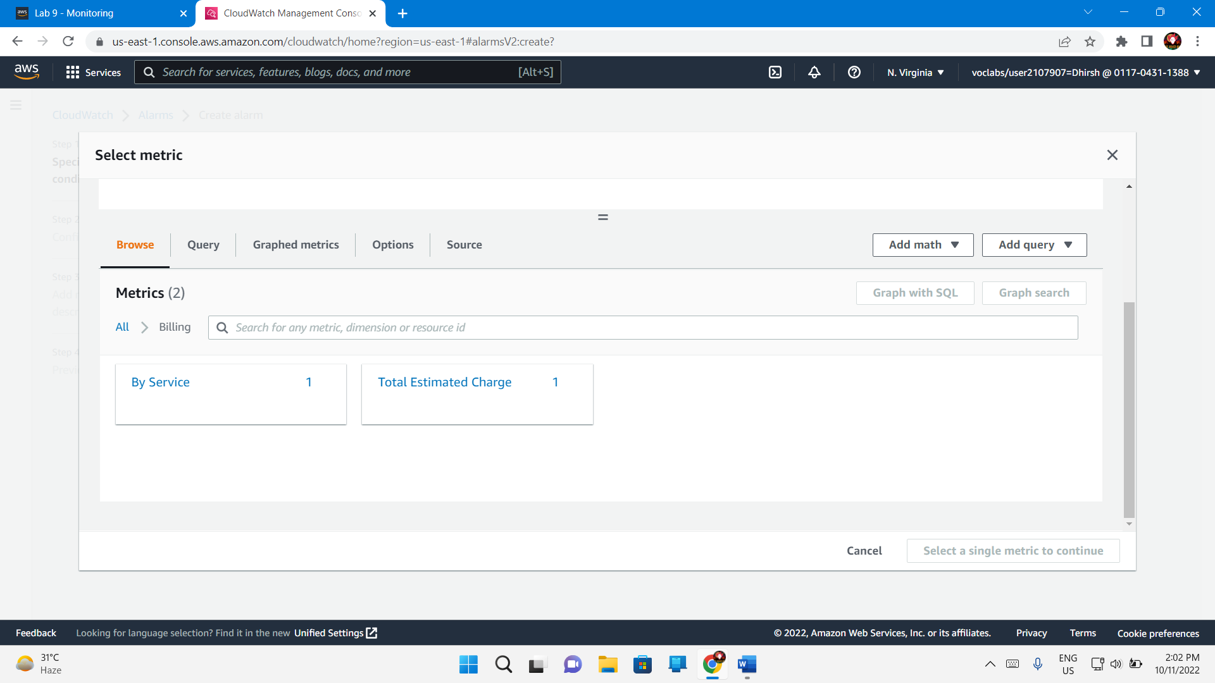

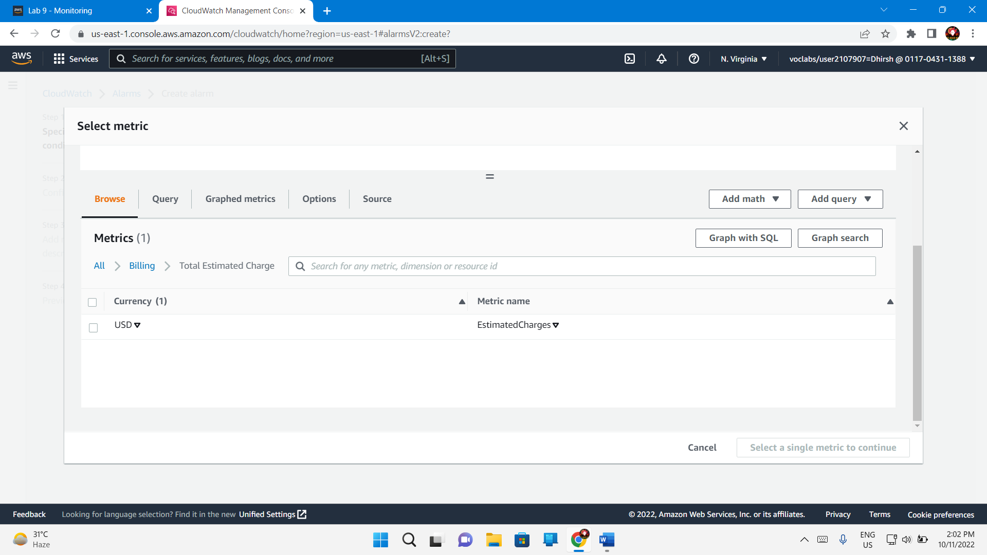

Estimated Charges

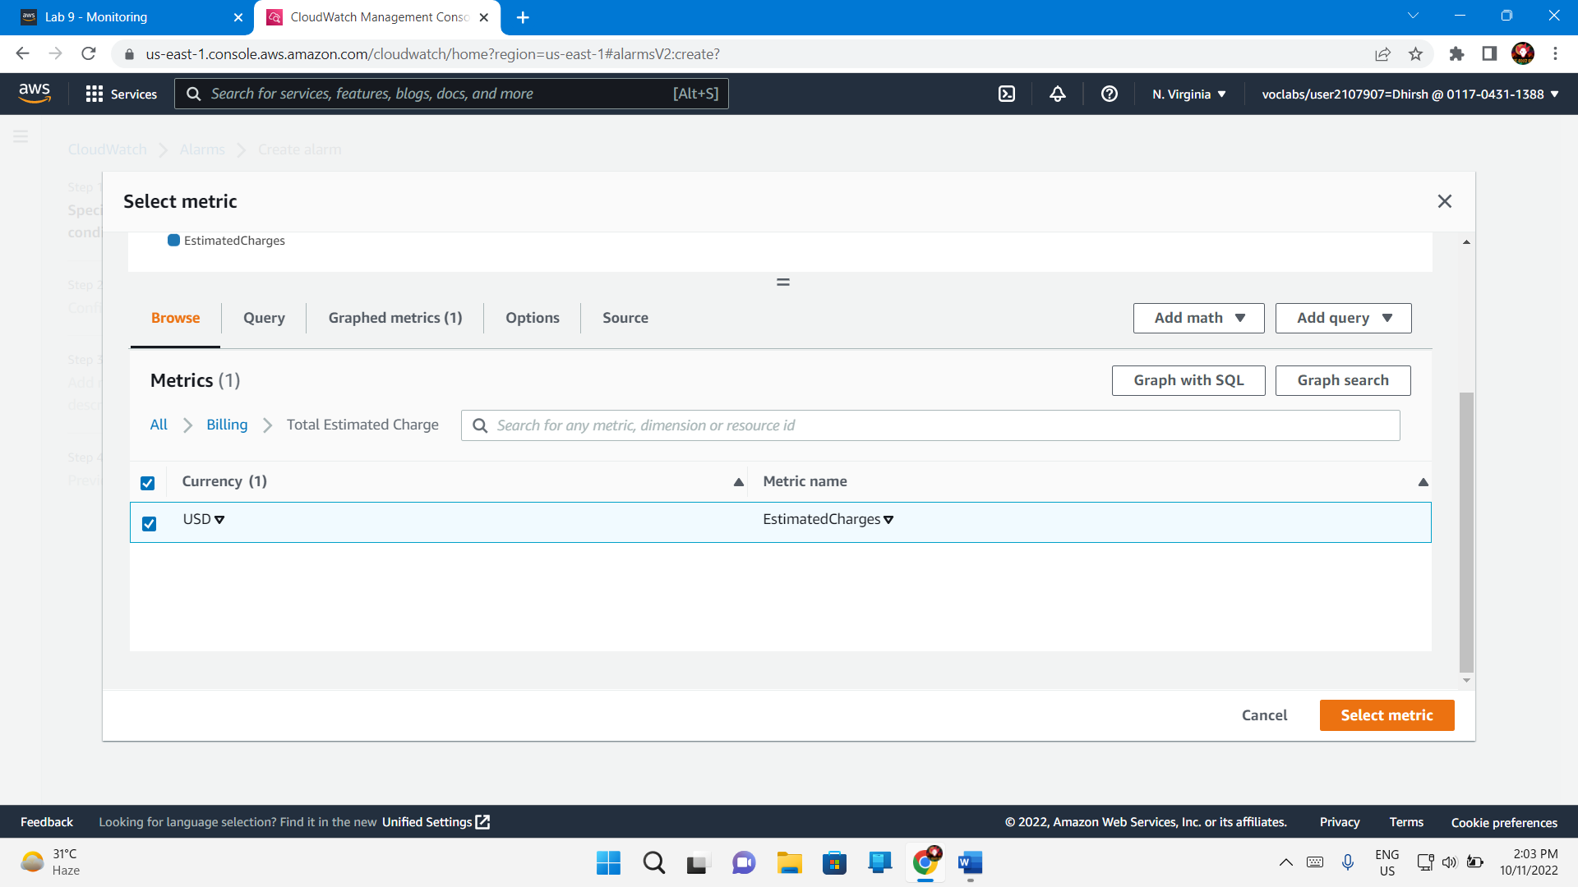

Threshold type – Static

Whenever estimated charges – Greater

Than .. – 100

Next

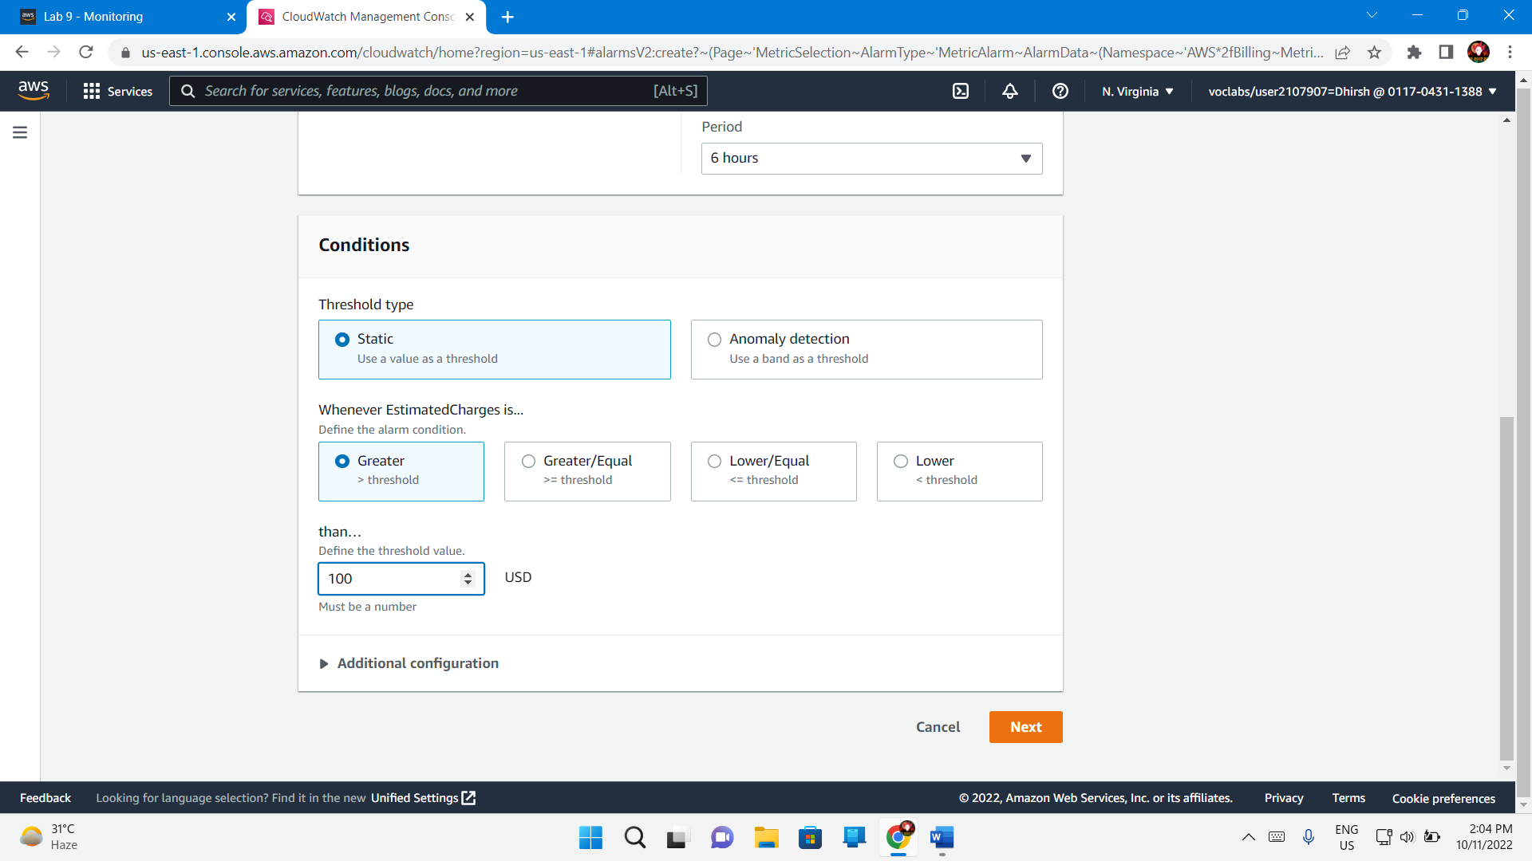

In the **Notification** section, configure the following:

* + For **Alarm state trigger**, choose **In alarm**.
  + For **Select an SNS topic**, choose **Select an existing SNS topic**.
  + For **Send a notification to...**, choose the **MoneyAlert** topic

Next

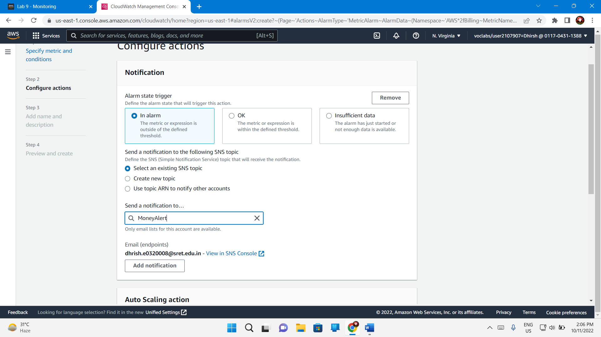

1. For **Alarm name**, enter MoneyAlertAlarm

Create Alarm

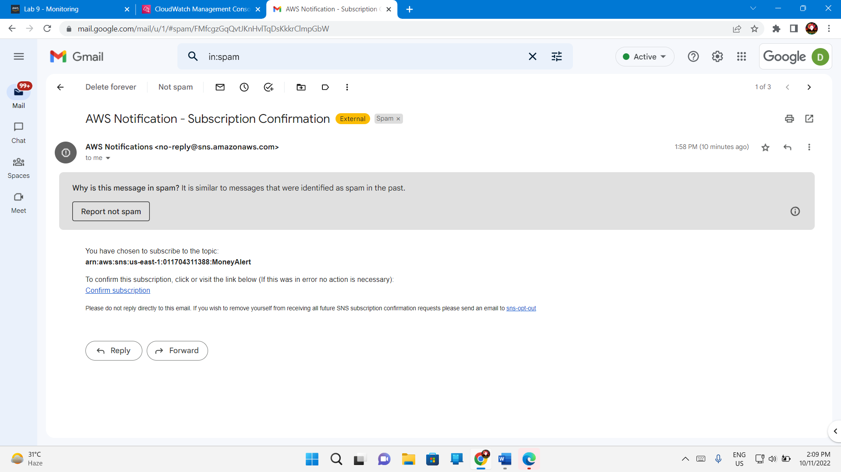

Congratulations! You have set up a CloudWatch alarm that uses Amazon SNS to send an alert when the cost of services reaches $100.